1.a

Instance: LINUX1 :::::::18.188.86.155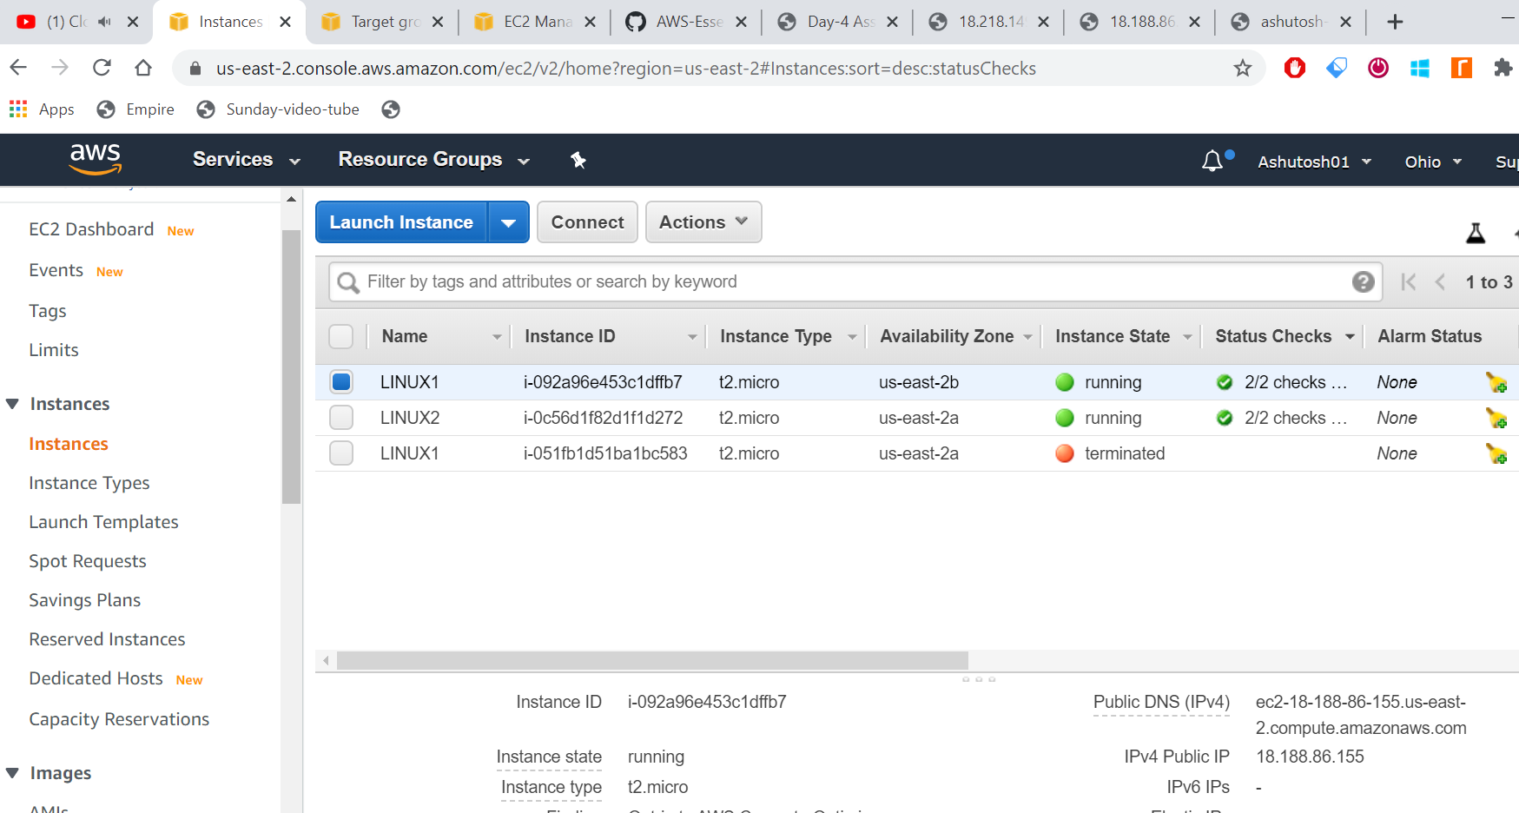

1.b Webpage for LINUX1

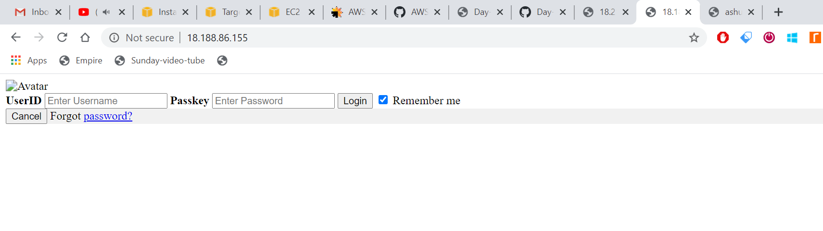

2. Instance: LINUX2::::::::::18.218.149.255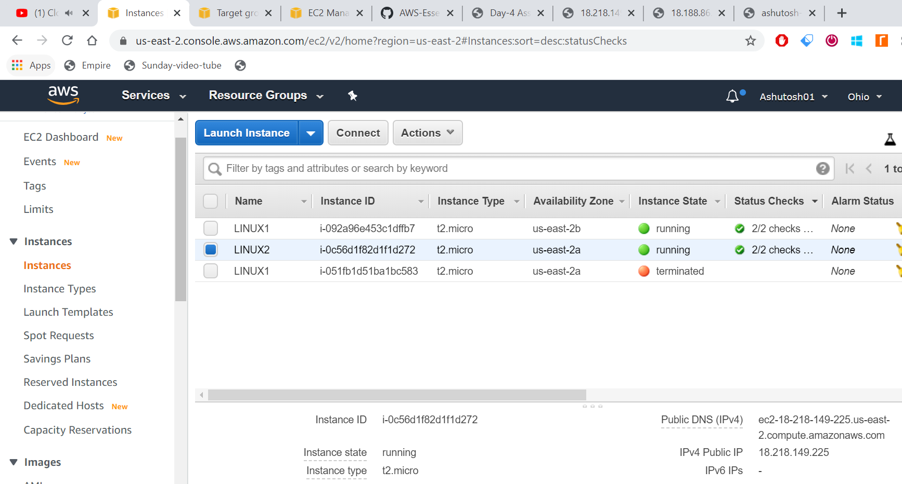

2.b Webpage for LINUX2

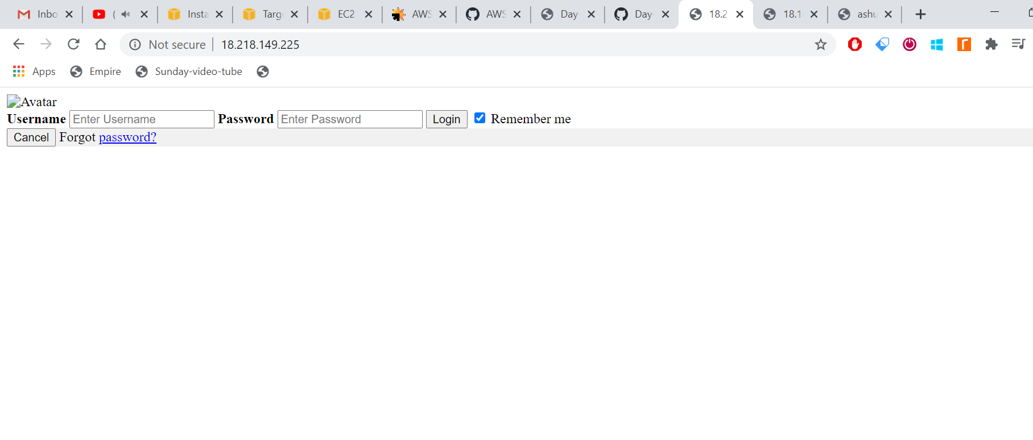

3.a DNS name for LOAD BALANCER:::Ashutosh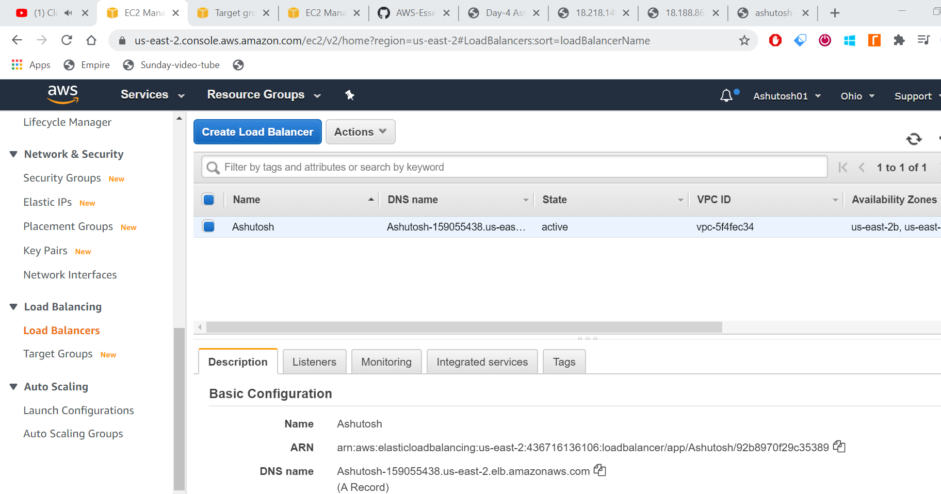

3. LOAD BALANCER ::Server 1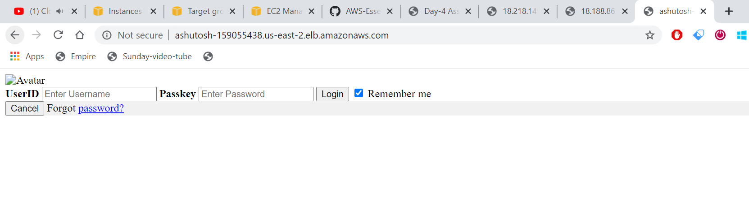

4. LOAD BALANCER ::Server 2